DATA MINING -HW2

IE 6318-001

FALL 2019

SUBMITTED ON SEPTEMBER 30, 2019



**SUBMITTED BY**

DEEPAK RAM BALA BOOPATHY (1001671704)

**2. Explore the Iris dataset and report the following:**

1) 2D scatter plots of the four attributes.

**CODE:**

clear all;

clc;

close all;

%Load feat and label from iris.txt

data = load(['iris.txt']);

feat = data(:,1:4); % feature matrix

label = data(:,5); % class label vector

%2.1 2D scatter plot of four attributes

gplotmatrix(feat, feat, label);

title('2D pairwise scatter plot of the four attributes', 'fontsize', 16, 'fontweight', 'bold');

**OUTPUT:**

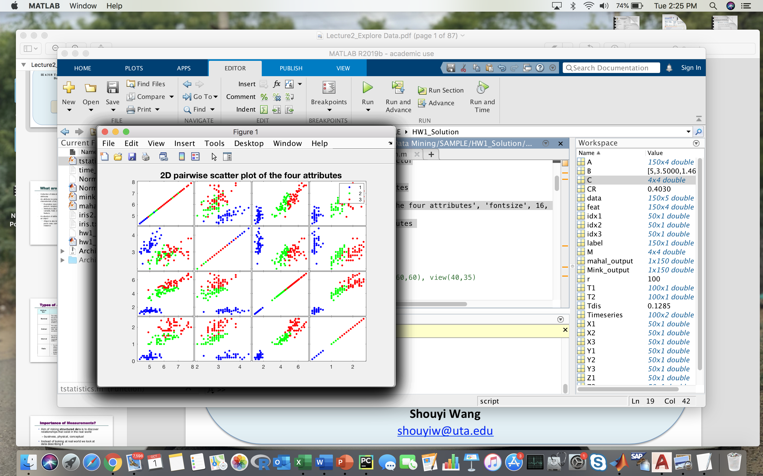

2) 3D scatter plot of three attributes.

**CODE:**

%2.2 3D scatter plot of three attributes

figure;

dx1 = find(label==1);

X1 = feat(idx1,1);

Y1 = feat(idx1,2);

Z1 = feat(idx1,3);

scatter3(X1(:),Y1(:),Z1(:));

hold on;

dx2 = find(label==2);

X2 = feat(idx2,1);

Y2 = feat(idx2,2);

Z2 = feat(idx2,3);

scatter3(X2(:),Y2(:),Z2(:));

hold on;

dx3 = find(label==3);

X3 = feat(idx3,1);

Y3 = feat(idx3,2);

Z3 = feat(idx3,3);

scatter3(X3(:),Y3(:),Z3(:), 'filled');

title('3D Scatter Plots of Three Features');

xlabel('sepal length');

ylabel('sepal width');

zlabel('petal length');

figure;

imagesc(feat); colorbar;

**OUTPUT:**

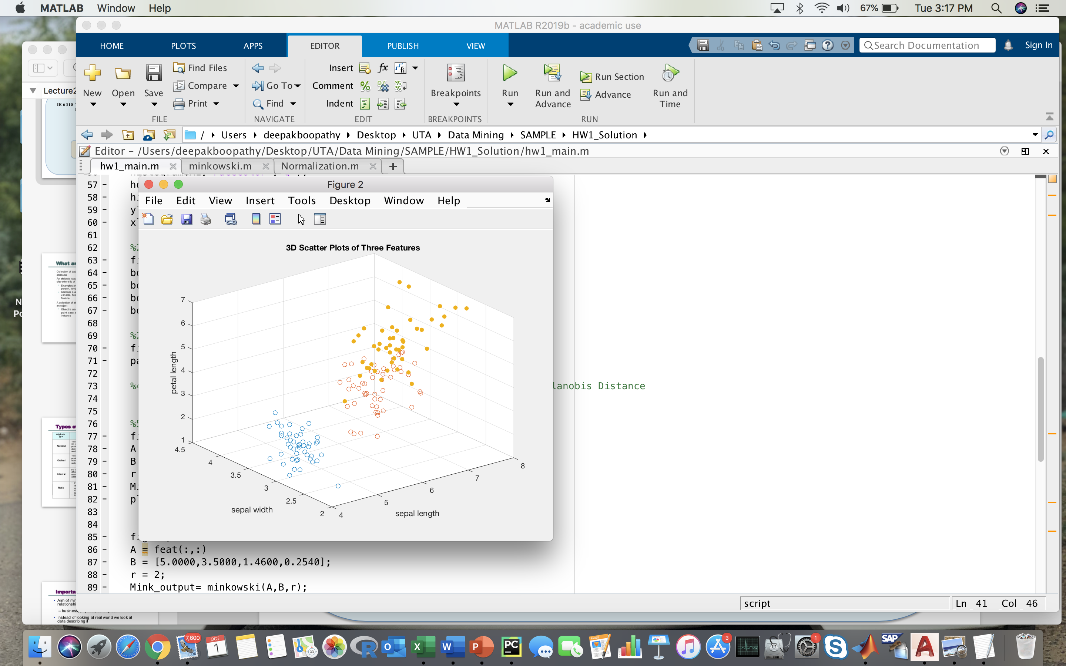

3) Visualization of the feature matrix (column 1-4).

**CODE:**

figure;

C = corr(feat);

imagesc(C); colorbar;

**OUTPUT:**

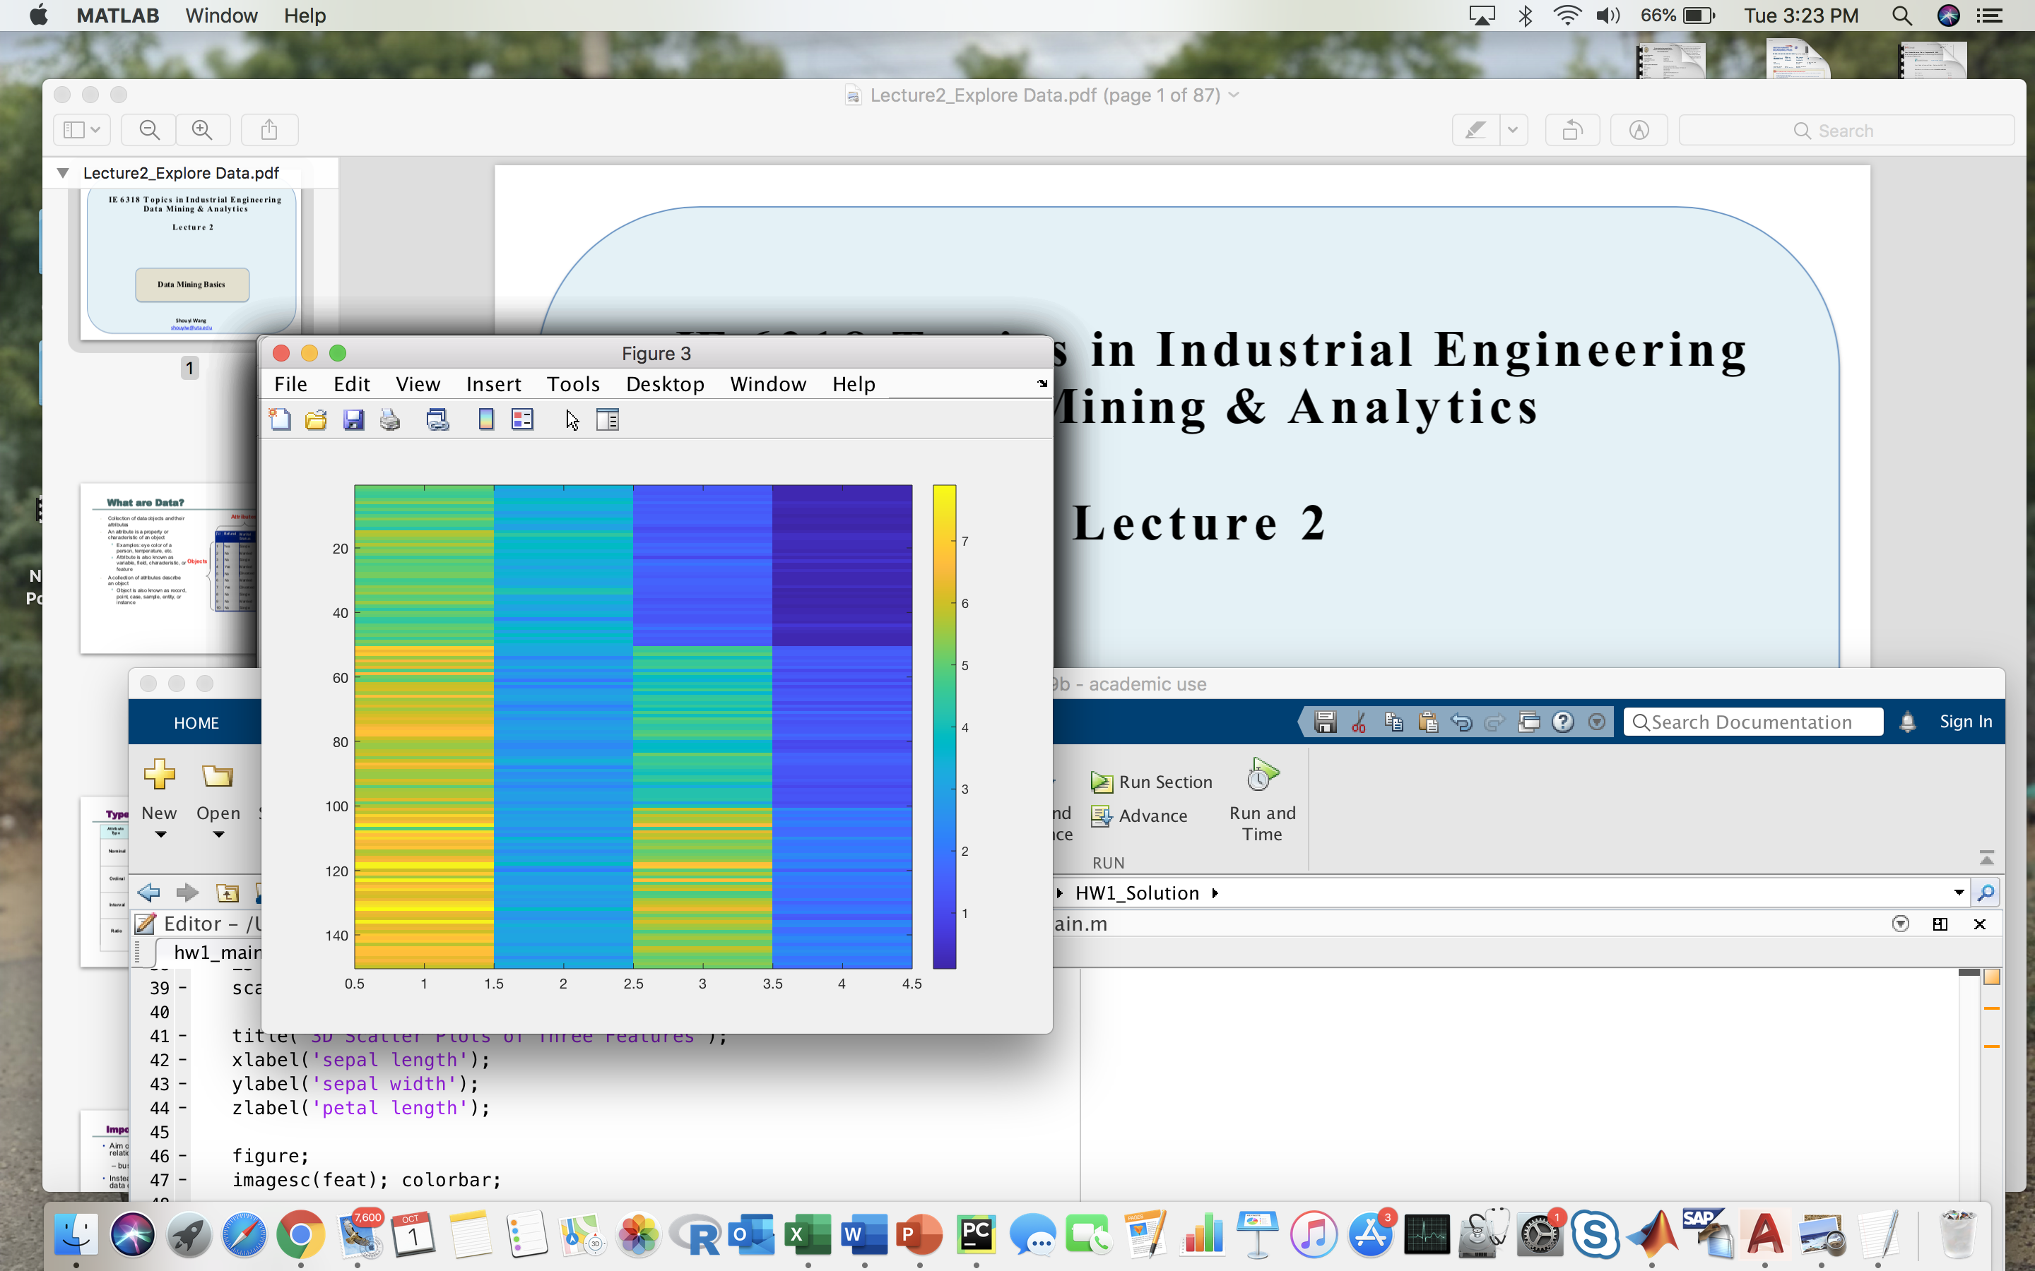

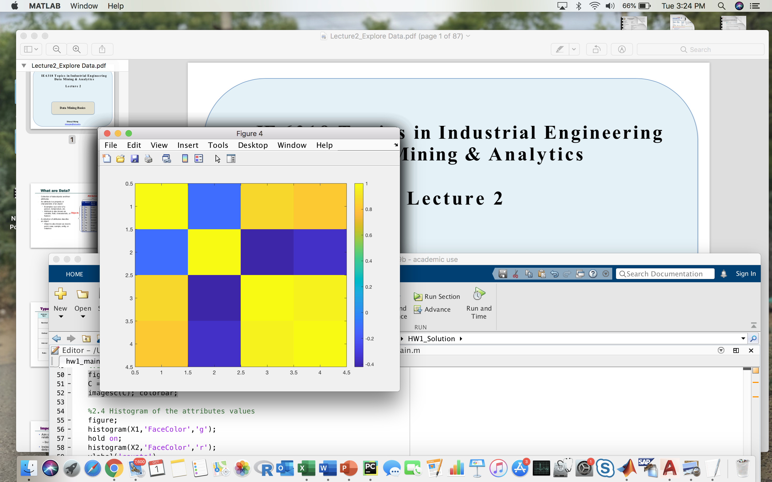

4) Histogram of the four attributes for the three classes.

**CODE:**

figure;

histogram(X1,'FaceColor','g');

hold on;

histogram(X2,'FaceColor','r');

ylabel('counts')

xlabel('data range');

**OUTPUT:**

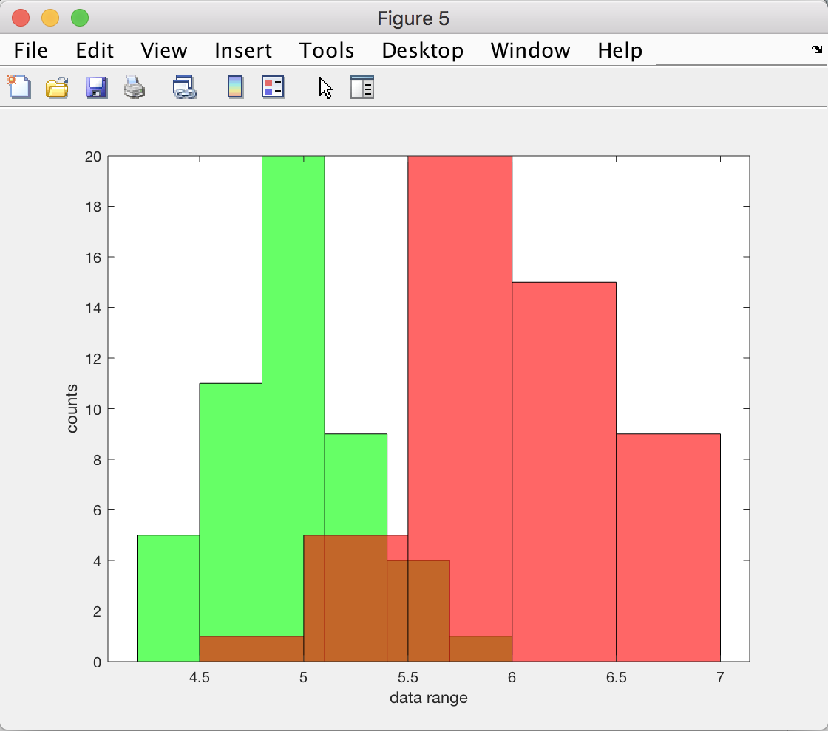

5) Boxplots of the four attributes for the three classes.

**CODE:**

figure;

boxplot(feat(:,1),label);

boxplot(feat(:,2),label);

boxplot(feat(:,3),label);

boxplot(feat(:,4),label);

**OUTPUT:**

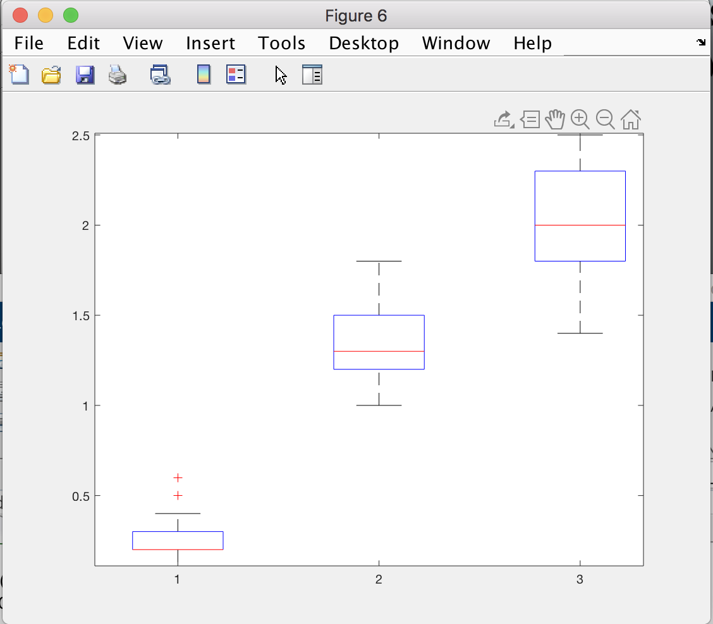

6) Parallel coordinates plot of the four attributes.

**CODE:**

figure;

parallelcoords(feat, 'group', label);

**OUTPUT:**

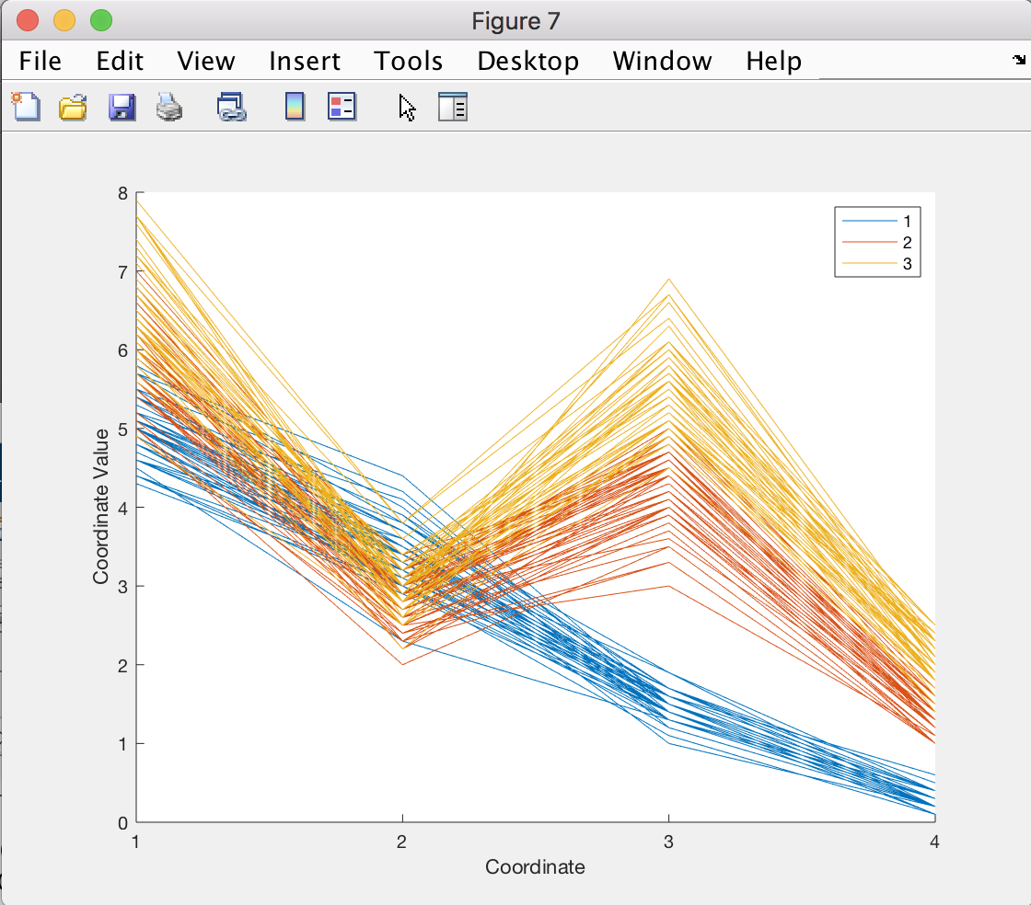

**3. Normalize the feature matrix of the IRIS dataset such that after normalization each feature has a mean of 0 and a standard deviation of 1. Calculate the correlation and covariance matrix of the four attributes before and after normalization.**

**CODE:**

close all;

data = load(['iris.txt']);

feat = data(:,1:4); % feature matrix

label = data(:,5); % class label vector

% Normalization Matrix

z = zscore(feat) %Normalized matrix

CV = cov(feat) %Covariance matrix before Normalization

CVV = cov(z) %Covariance matrix after Normalization

CP = corr(feat) %Correlation matrix before Normalization

CPP = corr(z) %Correlation matrix after Normalization

**OUTPUT:**

CV =

0.6857 -0.0393 1.2737 0.5169

-0.0393 0.1880 -0.3217 -0.1180

1.2737 -0.3217 3.1132 1.2964

0.5169 -0.1180 1.2964 0.5824

CVV =

1.0000 -0.1094 0.8718 0.8180

-0.1094 1.0000 -0.4205 -0.3565

0.8718 -0.4205 1.0000 0.9628

0.8180 -0.3565 0.9628 1.0000

CP =

1.0000 -0.1094 0.8718 0.8180

-0.1094 1.0000 -0.4205 -0.3565

0.8718 -0.4205 1.0000 0.9628

0.8180 -0.3565 0.9628 1.0000

CPP =

1.0000 -0.1094 0.8718 0.8180

-0.1094 1.0000 -0.4205 -0.3565

0.8718 -0.4205 1.0000 0.9628

0.8180 -0.3565 0.9628 1.0000

**4. Practice Data Distance Measures**

1) Make a function for Minkowski Distance. (3 function inputs: vector A, vector B, and order r)

**CODE:**

function [Mink_out] = minkowski(A,B,r)

for i=1:150

Mink_out(i)=(sum((abs(A(i,:)-B)).^r).^(1/r));

End

2) Make a function for T-statistics Distance. (3 function inputs: time series A, time series B)

**CODE:**

function [ mahal_output ] = mahalanobis(A,B,M)

%UNTITLED6 Summary of this function goes here

% Detailed explanation goes here

P = inv(M);

for i= 1:150;

mahal_output(i)= (A(i,:)-B)*P*(transpose(A(i,:)-B));

end

3) Make a function for Mahalanobis Distance. (3 function inputs: vector A, vector B, and covariance matrix M)

**CODE:**

function [tstat] = tstatistics(A,B)

%UNTITLED2 Summary of this function goes here

% Detailed explanation goes here

for i=1:100

tstat = ((abs(mean(A)-mean(B)))/std(A-B));

end

**5. For a new iris sample S with a feature vector of [5.0000, 3.5000, 1.4600, 0.2540]. Calculate the distances between the new sample and the 150 samples in the iris dataset using the distance functions you made.**

1) Calculate Minkowski distances with r = 1, 2, 10, respectively, and plot the obtained distances.

**CODE:**

%5.1 Calculate Minkowski distances

%For r=1

figure;

A = feat(:,:);

B = [5.0000,3.5000,1.4600,0.2540];

r = 1;

mink_out= minkowski(A,B,r);

plot(mink_out);

%For r=2

figure;

A = feat(:,:)

B = [5.0000,3.5000,1.4600,0.2540];

r = 2;

mink_out= minkowski(A,B,r);

plot(mink_out);

%For r=10

figure;

A = feat(:,:);

B = [5.0000,3.5000,1.4600,0.2540];

r = 100;

mink_out= minkowski(A,B,r);

plot(mink_out);

**OUTPUT:**

**r=1**

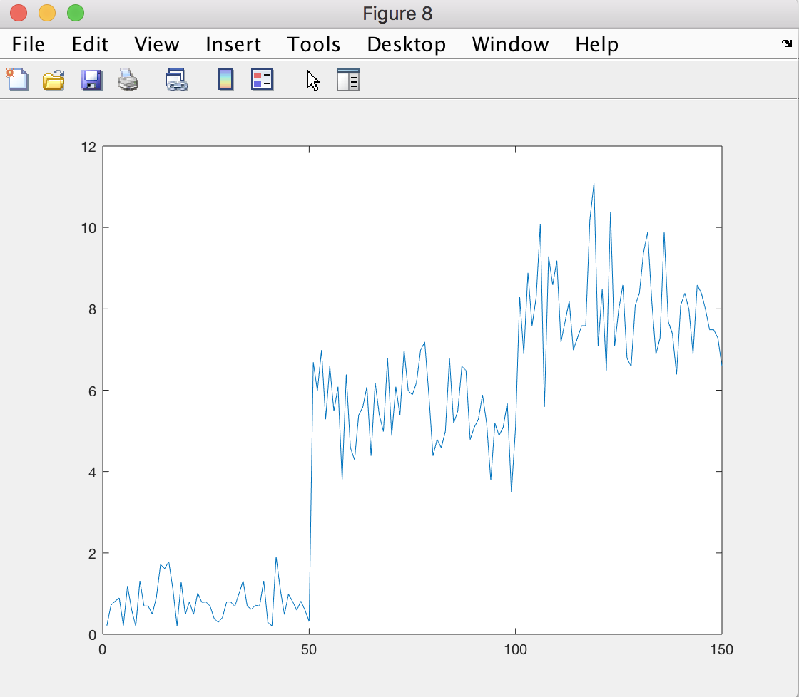

**r=2**

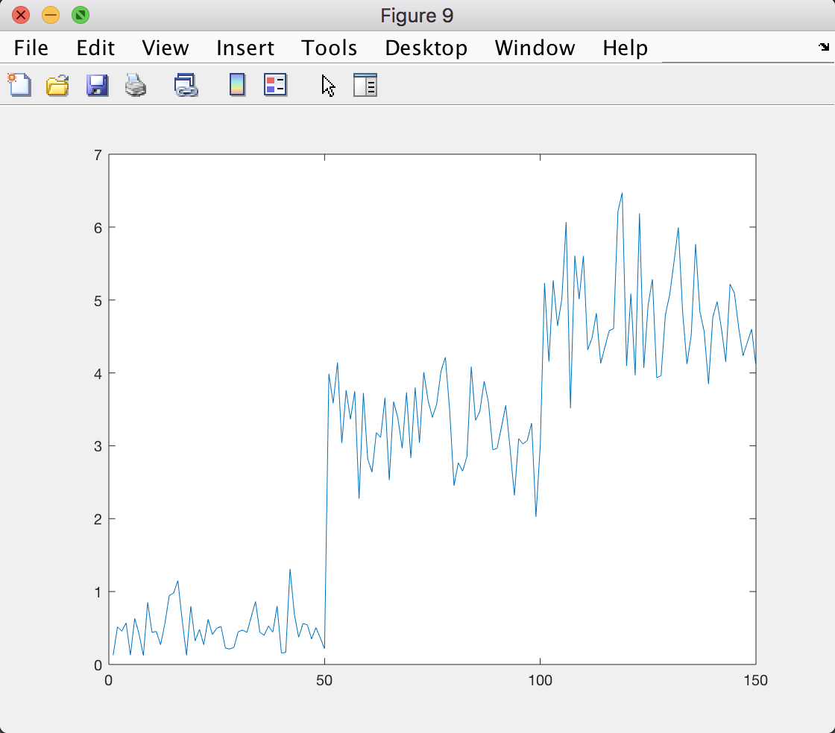

**r=10**

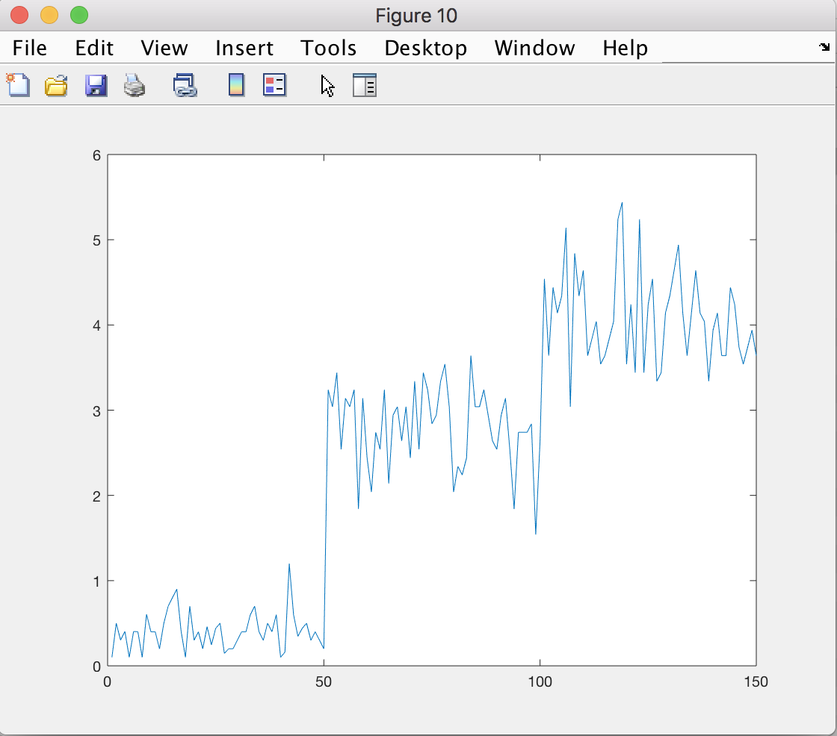

2) Calculate Mahalanobis distances and plot the obtained distances.

**CODE:**

figure;

A = feat(:,:);

B = [5.0000,3.5000,1.4600,0.2540];

M = cov(A);

mahal_output = mahalanobis(A,B,M);

plot(mahal_output);

**OUTPUT:**

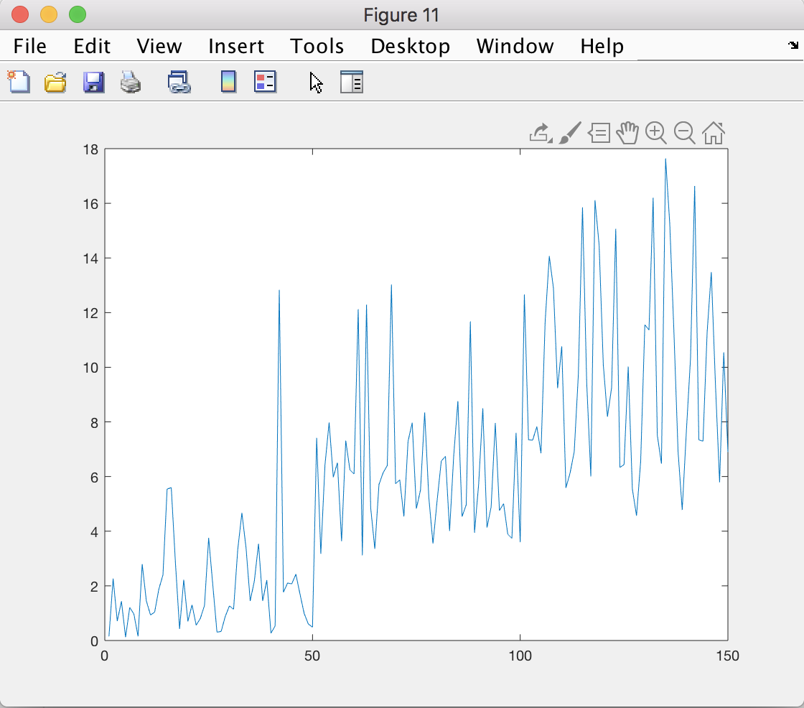

**6. We provide a dataset with two time series in “time_series_data_hw2.txt” file. Perform the following analysis**:

1) Plot the two time series in one plot

**CODE:**

%6.1 import Timeseries

Timeseries = load(['time_series.txt']);

figure;

T1 = Timeseries(:,1);

T2 = Timeseries(:,2);

plot(T1);

hold on;

plot(T2);

**OUTPUT:**

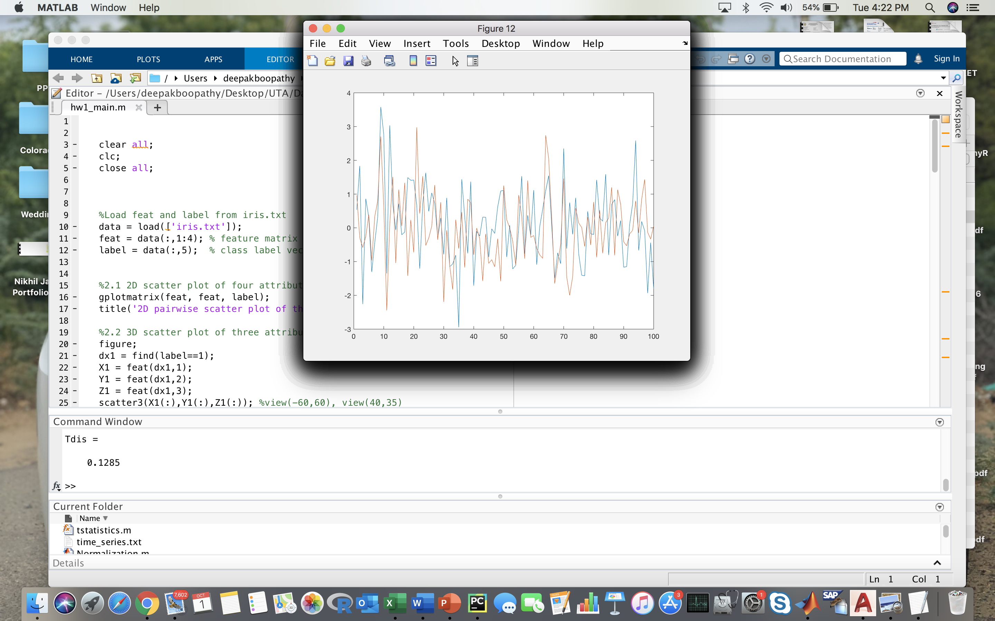

2) Calculate the T-statistics distance between the two time series

**CODE:**

%6.2 T-statistics for the two time series

Tdis = tstatistics(T1,T2)

**OUTPUT:**

Tdis =

0.1285

3) Calculate the correlation of the two time series

**CODE:**

%6.3 Correlation of the two time series data

CR = corr(T1,T2);

**OUTPUT:**

A B

A 1.000000 0.403044

B 0.403044 1.000000